LAB 7
9. implement of unification in FOL

def occurs_check(var, term, subs):
"""Check if var occurs in term (to prevent infinite recursion like x = f(x))"""
if var == term:
return True
if isinstance(term, tuple):
for t in term[1:]:
if occurs_check(var, apply_subs(t, subs), subs):
return True
return False

def apply_subs(term, subs):
"""Apply current substitutions to a term."""
if isinstance(term, str):
return subs.get(term, term)
if isinstance(term, tuple):
return tuple([term[0]] + [apply_subs(t, subs) for t in term[1:]])
return term

def unify(e1, e2, subs=None):
"""Main Unification function."""
if subs is None:
subs = {}
e1 = apply_subs(e1, subs)
e2 = apply_subs(e2, subs)

# If both terms are same, nothing to do
if e1 == e2:
return subs

# If one is variable (lowercase)
if isinstance(e1, str) and e1.islower():
return unify_var(e1, e2, subs)
if isinstance(e2, str) and e2.islower():
return unify_var(e2, e1, subs)

# If both are compound terms (predicates)
if isinstance(e1, tuple) and isinstance(e2, tuple):
if e1[0] != e2[0] or len(e1) != len(e2):
return None # Predicate/function mismatch
for i in range(1, len(e1)):
subs = unify(e1[i], e2[i], subs)
if subs is None:
return None
return subs

# Otherwise not unifiable
return None

def unify_var(var, x, subs):
"""Bind a variable to a term if possible."""
if var in subs:
return unify(subs[var], x, subs)
elif x in subs:
return unify(var, subs[x], subs)
elif occurs_check(var, x, subs):
return None
else:
subs[var] = x
return subs

# ---------- Example Usage ----------

# Example 1
exp1 = ('p', 'x', 'a')
exp2 = ('p', 'b', 'y')

print("\nExpression 1:", exp1)
print("Expression 2:", exp2)

result = unify(exp1, exp2, {})

if result:
print("\n✅ Unification Successful!")
print("Unifier:", result)
else:
print("\n❌ Unification Failed.")
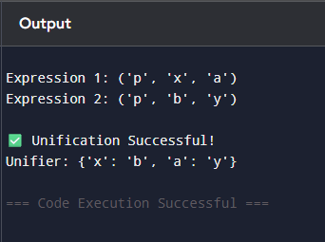

11. Create a knowledge base consisting of first order logic statements and prove the
given query using forward reasoning.
Knowledge Base (First-Order Logic Statements):
- Man(Marcus): Marcus is a man.
- Pompeian(Marcus): Marcus is a Pompeian.
- All(x) (Pompeian(x) -> Roman(x)): All Pompeians are Romans.
- All(x) (Roman(x) -> Loyal(x)): All Romans are loyal.
- All(x) (Man(x) -> Person(x)): All men are persons.
- All(x) (Person(x) -> Mortal(x)): All persons are mortal.
Query:
Mortal(Marcus): Is Marcus mortal?
# Forward chaining demonstration for Marcus KB
# Prints full steps (which rule applied, which premises matched, resulting fact)

def pretty_fact(pred, const):
return f"{pred}({const})"

# Initial ground facts
facts = set([
("Man", "Marcus"),
("Pompeian", "Marcus")
])

# Rules of the form (premise_predicate, conclusion_predicate)
rules = [
("Pompeian", "Roman"), # ∀x (Pompeian(x) -> Roman(x))
("Roman", "Loyal"), # ∀x (Roman(x) -> Loyal(x))
("Man", "Person"), # ∀x (Man(x) -> Person(x))
("Person", "Mortal") # ∀x (Person(x) -> Mortal(x))
]

query = ("Mortal", "Marcus")

# Helper to print current KB nicely
def print_kb(facts):
return ", ".join(sorted([pretty_fact(p,c) for (p,c) in facts]))

# Forward chaining engine with full trace
def forward_chain_with_steps(facts, rules, query):
print("Initial Facts:")
print(" " + print_kb(facts))
print("\nRules:")
for i, (prem, concl) in enumerate(rules, start=1):
print(f" R{i}: ∀x ({prem}(x) -> {concl}(x))")
print("\nStarting forward chaining...\n")

derived_order = [] # list of tuples (new_fact, rule_index, matched_fact)
changed = True
iteration = 0
while changed:
iteration += 1
changed = False
print(f"--- Iteration {iteration} ---")
# try each rule
for ri, (prem, concl) in enumerate(rules, start=1):
# check all facts for a match to premise
for fact in list(facts): # list() to allow modification of facts inside loop
pred, const = fact
if pred == prem:
# instantiate conclusion with this constant
new_fact = (concl, const)
if new_fact not in facts:
# derive new fact
facts.add(new_fact)
derived_order.append((new_fact, ri, fact))
changed = True
print(f"Derived {pretty_fact(*new_fact)} using Rule R{ri}: "
f"{pretty_fact(*fact)} => {pretty_fact(*new_fact)}")
# If query found, we can still continue to show other derivations in this iteration,
# but we will later report success.
if not changed:
print("No new facts derived in this iteration.")
print("Current KB:", print_kb(facts), "\n")

# Optionally short-circuit if query is found
if query in facts:
print("Query found in KB. Forward chaining can stop successfully.\n")
return True, facts, derived_order

print("No more rules apply and query not found.\n")
return (query in facts), facts, derived_order

# Run the forward chaining process
proved, final_facts, derivations = forward_chain_with_steps(set(facts), rules, query)

# Final summary
print("=== Final Summary ===")
print("Final Knowledge Base:")
print(" " + print_kb(final_facts))
print("\nDerivation trace (in order):")
for idx, (nf, ri, matched) in enumerate(derivations, start=1):
print(f" Step {idx}: Derived {pretty_fact(*nf)} using Rule R{ri} from {pretty_fact(*matched)}")

if proved:
print(f"\nResult: ✅ The query {pretty_fact(*query)} is PROVED by forward chaining.")
else:
print(f"\nResult: ❌ The query {pretty_fact(*query)} CANNOT be proved by forward chaining.")
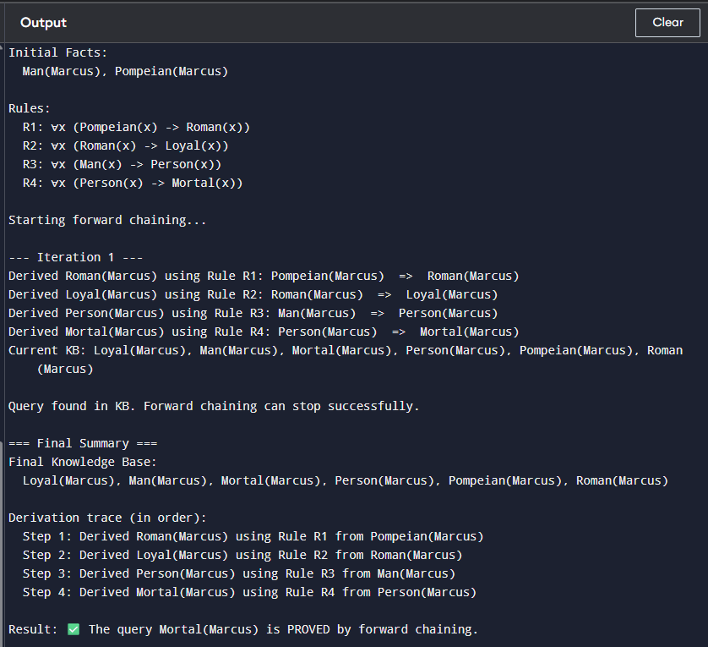

10. Convert a given first order logic statement into Conjunctive Normal Form (CNF)
# Convert a given First-Order Logic statement into Conjunctive Normal Form (CNF)
# Example: ∀x [ (∃y (Animal(y) ∨ Loves(x, y))) ∨ (∃z Loves(z, x)) ]

from sympy import symbols, Function, Or, And, Not, Implies, to_cnf, Exists, ForAll

# Define predicate symbols
x, y, z = symbols('x y z')
Animal = Function('Animal')
Loves = Function('Loves')

print("\n=== Step 1: Original FOL Statement ===")
formula = ForAll(x, Or(Exists(y, Or(Animal(y), Loves(x, y))),
Exists(z, Loves(z, x))))
print("∀x [ (∃y (Animal(y) ∨ Loves(x,y))) ∨ (∃z Loves(z,x)) ]")

print("\n=== Step 2: Remove implications (→) ===")
print("No implications in the formula, so we keep it as is.")

print("\n=== Step 3: Move negations inward ===")
print("No negations to push inward here.")

print("\n=== Step 4: Standardize variables ===")
print("Variables are already standardized: y, z are distinct inside their quantifiers.")

print("\n=== Step 5: Skolemization ===")
print("We replace existential variables with Skolem functions of universally quantified ones:")
print(" ∃y → y = f(x)")
print(" ∃z → z = g(x)")
print("Formula becomes: ∀x [ (Animal(f(x)) ∨ Loves(x,f(x))) ∨ Loves(g(x),x) ]")

print("\n=== Step 6: Drop universal quantifier (∀x) ===")
print("After Skolemization, all remaining variables are universally quantified implicitly.")
print("So we remove ∀x:")
print(" (Animal(f(x)) ∨ Loves(x,f(x)) ∨ Loves(g(x),x))")

print("\n=== Step 7: CNF Conversion ===")
cnf_formula = to_cnf(Or(Animal(Function('f')(x)),
Loves(x, Function('f')(x)),
Loves(Function('g')(x), x)), simplify=True)
print("Final CNF clause form:", cnf_formula)

print("\n=== Step 8: Clause Representation ===")
print("{ Animal(f(x)) ∨ Loves(x,f(x)) ∨ Loves(g(x),x) }")

